Is Egypt’s Rural Youth Employment Vulnerable to Climate Change?

Abstract
The slow rate of job creation in the public and private formal sector has pushed the youth of Egypt to either exit the labor market or to accept jobs in the informal/irregular sector. These jobs are highly insecure and unstable. This paper goes beyond studying the labor market performance by analyzing the unemployed and out of labor force into studying the employment vulnerability by being in informal/irregular jobs. The study combines the impact of socioeconomic variables in addition to climate change variables to understand the determinants of vulnerable employment and more so among rural youth. We combine data from the ELMPS and geographically gridded daily measures of climate change. Our results show the persistence of employment vulnerability among youth with a stronger impact on rural youth. changes in temperature and humidity show a significant impact on employment vulnerability among rural youth.

Keywords: Climate, Temperature, Humidity, Vulnerable employment, Egypt, Multinomial logistic regressions.
JEL Classification: Q54, N35, J21, C35

- Introduction and motivation
Vulnerable groups are those who are weak, threatened or can be easily harmed or attacked. It is a relative state which implies that a group is more exposed to risks compared to others. Vulnerability is also dependent on the type of risk and the nature of the group exposed to that risk. Youth employment vulnerability therefore shows that the young people are exposed to more risky labor market outcomes as compared to their peers of other age groups. During the transition to adulthood, young people can be “attributed to challenges like educational performance, unemployment, migration and others” (Quick et al. 2014).

The demographic dominance of the young population over the working population has contributed to a large base of job seekers, while job creation was not able to keep up with this growth. Despite the temporary slowdown in the population growth and the number of new entrants to the labor market, unemployment rates remained high, and the time taken to exit the state of unemployment among the young and educated Egyptians remained high (Barsoum et al. 2014).

Youth unemployment has for long been a main concern in Egypt, recording high rates of unemployment among the young population and the educated ones (Assaad 2007). The plight of youth unemployment in Egypt has its roots in the high rates among the more financially able and educated as compared to the poor and the less educated. Assaad and Krafft (2015) reported that the educated young people from higher social backgrounds who could afford to stay longer without a job because they were supported by their parents constituted most of the pool of unemployed young people. The less educated and less financially able young people, on the other hand, cannot afford to stay without a job due to the financial constraints they face and resort to the informal sector. According to El-Laithy et al. (2003), “….(t)he Egyptian poor tend to live in large families, have low levels of education, work in the informal sector and be concentrated in low-paying unskilled activities”(p. 14).. Accordingly, high youth unemployment, high levels of informality, and low-quality jobs are the main adverse outcomes of the Egyptian labor market.

The current situation of the labor market outcome for Egyptian youths and the spread of unemployment and informality in addition to the economic, social, and political instabilities has led to this state of vulnerability. The capacity of the public sector (as the main employer) to create more jobs has decreased or disappeared altogether. Microenterprises and entrepreneurship have appeared as a main source of formal employment and job creation. Despite creating most of the jobs, the small size nature of the enterprises has limited their capacity to absorb the increasing labor force. This limited role of the public sector and the limited capacity of the private formal sector to absorb the growing labor force, especially at times of political and economic uncertainties, have paved the way for the private informal sector (ECES, 2020).

Informality and job insecurity is considered a more alarming problem in the Egyptian labor market (Assaad et al. 2019). Youth who are employed are suffering from informality, lacking job security and other forms of stability including paid leaves, health and social insurance and contracts. The worsening labor market conditions in Egypt are limiting the options for youth to engage in a formal job, whether in the public or the private sector, and therefore job vulnerability is considered a main concern among the employed. This vulnerability is emphasizing the intergenerational inequality in outcome and inequality in opportunity especially among the youth and is reinforcing poverty and deprivation (Hlasny and AlAzzawi, 2018).

Climate change is expected to have its impact on labor market outcomes. Climate change is exacerbating the difficulties workers are going through and is therefore expected to increase the vulnerability of workers. Climate change and the rise in temperature could drive economic opportunities from one place to another. This is expected to increase employment vulnerability, pushing people more towards informality and irregularity in the labor market (World Bank, 2019).

The general issue this paper is addressing is not the unemployment or inactivity of youth, but rather the informality and insecurity of employment in the era of global warming. It is time we look beyond the unemployment rate and inactivity rate to measure the performance of the labor market, where the quality and stability of these jobs brought to the youth is of more importance. The paper discusses this vulnerability in the rural areas, where formal jobs are scarce. This paper builds on the available literature defining employment vulnerability and aims to contribute to the literature by investigating the impact of climate change (measured by changes in temperature, precipitation, and humidity) on employment vulnerability in rural Egypt.

The paper uses data from two sources: Integrated Labor Market Panel Surveys (ILMPS) and a globally gridded weather dataset. Geographically gridded daily measures of climate change variables are matched to the ILMPS data. We aim to focus on three variables namely, maximum temperature, precipitation and relative humidity and investigate the individual contributions of workers’ circumstances. The analysis is further extended to include climate change variables as well as the respondents' individual-level characteristics to identify how respondents' vulnerability based on climatic changes is impacted by the respondent's characteristics such as age range, educational level and gender.

Using an unbalanced longitudinal survey data from the Integrated Labor Market Panel Survey (ILMPS) of Egypt (2006, 2012, 2018), this work seeks to examine the impact of changes in temperature, precipitation, and humidity on individual-level employment vulnerability. In the ILMPS data, the respondent is requested to report his/her employment status over the past week. We also use spatial daily climate indicators such as maximum temperature, precipitation, and humidity during the week for which the respondent is reporting the employment status.

The remainder of the paper is organized as follows. Section 2 describes the review of available literature and the value added. Section 3 describes the data used. Section 4 motivates and explains the applied methodology to estimate the effect of climate indicators on the vulnerability status in employment. This is followed by a discussion of the results in Section 5. Finally, section 6 concludes the main findings and policy implications.

- Review of literature and value added
  - Employment vulnerability
Assaad and others have referred to three necessary factors for a smooth transition to adulthood, namely education, employment, and family formation (Assaad et al. 2017). The three factors are interrelated, where an interruption to one of them would negatively affect the other leaving the young population in a state of vulnerability.

The International labor Organization (ILO) has reported that youth unemployment in Northern Africa is highest in the World (ILO 2020). In the third quarter of 2017, the overall unemployment rate stood at 11.9 percent, going down to 10 percent by the third quarter of 2018. The rate for the youths is higher, recording approximately 32 percent in 2018. The demographic structure for Egypt is showing a high rate of growth for the working age population (3.1 percent annually) with the labor force growing at 1.8 percent annually and employment growing only at 0.9 percent annually.

Unemployment rates were stubbornly high and not responding to the fluctuations in the growth rates. Therefore, Egypt has witnessed a significant rise in the unemployment rates, with a peak of 13 percent in 2013. Unemployment rates have since started to decline, reaching a national low of 10 percent in 2018. Youth unemployment (31%), however, remains a particular problem (ICMPD 2020).

Decomposing unemployment rates by gender and age groups, it is shown that youths represent approximately 80 percent of the total unemployed population in Egypt (with the highest rates among the 20-24 age group) (ETF, 2015). The situation for females is much worse than that of males of all age groups and through the years. Not only is unemployment a young people’s problem but unemployment figures become more significant among the higher educated of them.

In addition to the high and prevalent unemployment rates, the expansion of informality is having its impact on the quality of life and living standards of the individuals. The Egyptian Labor Market Panel Survey (ELMPS) shows that the informal sector is absorbing the younger generation and increases as one moves towards the rural sectors in Egypt. The spread of the informal sector in rural Egypt is mainly resulting from the limited access to finance and social networks compounded by the high levels of poverty (Abou-Ali and Rizk 2015). This is confirmed by the spread of informality across the poorest wealth quintiles.

Hlasny and Al Azzawi refer to this informality and irregularity in the job market as employment vulnerability (Hlasny and AlAzzawi, 2018). Assaad has also referred to the employment vulnerability rising at a time where the rates of employment have been declining, but unemployment has not been increasing (Assaad 2014b). This shows that the performance of the labor market requires alternative measures as emphasized by Assaad and Krafft (Assaad and Krafft 2014). Type of work, prevalence of irregularity, and informality are better measures of the health of the labor market.

  - Climate changes impacts on employment
The International Labor Organization (ILO) identified key aspects when addressing climate change impacts of work: the services that the ecosystem provides (as in the case in agriculture or tourism), working conditions in addition to risks and hazards on vulnerable workers (ILO 2018). Due to increased environmental hazards, labor productivity has reportedly decreased globally by 23 million working-life years between 2000 and 2015. Furthermore, it is projected that the total number of work hours will decrease by 1.9 percent by 2030. These impacts will include not only warm countries but also temperate regions (Adam-Poupart et al. 2013). This is especially true for unacclimatized workers that are exposed to increased frequency of heat waves.

Climate change was shown to have differential impacts on workers, based on attributes and type of their work. For example, a study examining the impacts of increasing weather temperatures in three Middle East countries found that work hours of workers were significantly impacted by changing weather temperature. However, high-risk workers were more sensitive to the temperature variability than low-risk workers (Abou-Ali et al. 2021). The study defined high-risk workers based on the nature of their work as ‘group whose occupations encounter high exposure to climate’. Other comparisons by the work sector revealed a reduction in workers availability in industries characterized by higher exposure to climate such as farming, construction, and other outdoor activities (Antonelli et al. 2020; Shayegh, Manoussi, and Dasgupta 2020). Subsequently, this may have grave impacts on vulnerable workers in Sub-Saharan Africa, where the dominant livelihood is small-scale farming, an outdoor activity practiced in small land-holdings (FAO 2012). In another study in Latin America, changing weather conditions and droughts has pushed populations that live-off livestock as a source of livelihood to other sources (Arora et al. 2017).

  - Value added
In this paper we contribute to the literature by examining the prevalence of employment vulnerability in rural Egypt during a period where labor market outcomes are affected by several external factors among which is climate change. Our paper stems from examining the literature which revealed that studies covering Egypt are scant. Labor market data is obtained from the ILMPS for Egypt covering the years 2006, 2012 and 2018. The data allows the dynamic analysis of the employment vulnerability through time as well as by age, gender, and geographic location. Examining the vulnerability of employment over time allows for understanding the extent of vulnerability and the role of time sensitive factors in the changing extent of vulnerability in the context of climate change.

- Data
This study relies on linking data from two sources: ILMPS, and globally gridded weather and climate datasets. ILMPS are nationally representative longitudinal datasets collected as a joint effort of the Economic Research Forum (ERF) and the national statistical offices where the surveys are held (OAMDI 2019). The labor marker modules of ILMPS are rich datasets focusing on employment, unemployment, earnings, and work-time indicators; yet, it also includes various modules that encompass indicators for parental background, education, housing, access to services, residential mobility, migration and remittances, time use, marriage patterns and costs, fertility, women's decision making and empowerment, job dynamics, savings and borrowing behavior, the operation of household enterprises and farms.
Geographically gridded daily measures of meteorological variables are matched to the ILMPS data. We focus on three weather variables namely, maximum temperature, precipitation, and relative humidity. Daily maximum temperature is obtained from National Oceanic and Atmospheric Administration (NOAA) Climate Prediction Center (CPC) Global Daily Temperature. Daily total surface precipitation is acquired from NOAA CPC Global United Gauge-Based Analysis of Daily Precipitation. Daily relative humidity is obtained from The National Aeronautics and Space Administration Prediction of Worldwide Energy Resources (NASA POWER) Project, which is funded through The National Aeronautics and Space Administration (NASA) Applied Sciences Program. Relative humidity is normally expressed as a percentage; a higher percentage means that the air-water mixture is more humid. Precipitation is measured in millimeters (mm) and temperature is reported in degrees Celsius (°C). The time span of these two datasets starts in year 1979 to date. The resolution of these three global datasets is 0.50-degree latitude x 0.50-degree longitude grid.

Using the climate datasets mentioned above, we first calculate the weekly averages of the 7-days preceding the survey dates for the three meteorology variables of interest. Afterwards, we match the calculated weekly climate averages with the ILMPS dataset based on the location of the respondent and the visit date of the interview. The Egyptian dataset of the ILMPS for 2006, 2012 and 2018 are selected. The second administrative unit (Markaz/Kism in Egypt) is used to identify and match the location of the household without revealing personally identified information of the sample units. This is applied to all the rounds of the survey data where the visit date is present, specifically for Egypt 2018, 2012, and 2006.
In other words, we exploit the spatial and temporal variation in our observations to capture the impact of changes in our three meteorological indicators on the number of hours worked by respondents per week.

- An overview on vulnerable employment and its determinants
Prior to exploring the methodology, we start by exploring the data on climate and vulnerable employment status as well as the different socio-economic indicators will be included in the estimated model. Figure 1 depicts the spatial distribution of the weekly average of the relative humidity and maximum temperature in Egypt, respectively.

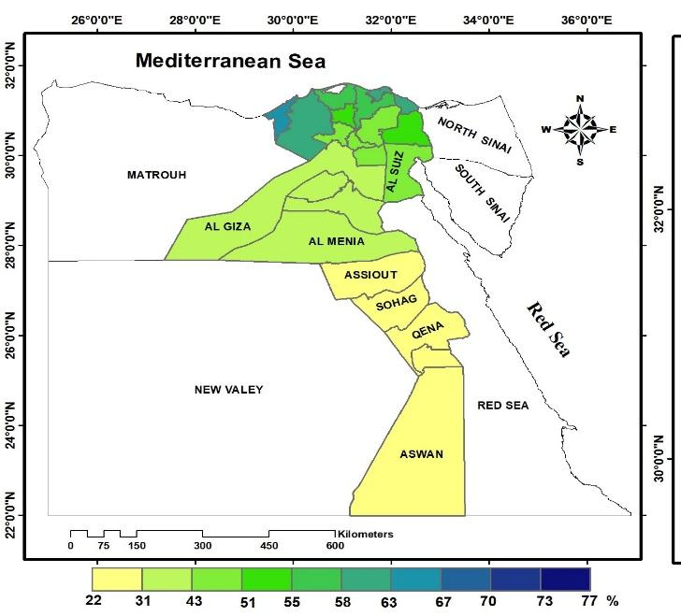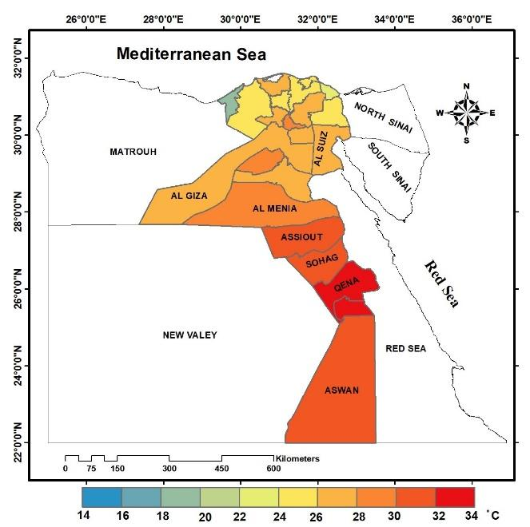
Figure 1: Weekly average of climate variables per governorate. On the right is relative humidity and the one on the left is maximum temperature.
Source: Authors’ graph using NASA POWER and NOAA CPC Global daily temperature.

As for the vulnerable employment, the most vulnerable groups are ones who cannot afford to stay unemployed or out of the labor force and are thus accepting informal or irregular jobs or become self-employed. The first step is to define vulnerable employment. Hlasny and AlAzzawi follow the World Bank definition of vulnerable employment as “the total of unpaid family workers, self-employed, irregular wage workers and informal private sector workers” (Hlasny and AlAzzawi, 2018). In this paper we follow the same definition of vulnerable employment. These employment statuses share the lack of formality and regularity represented in the contract and social insurance as the main factors. The World Bank emphasizes that these employment outcomes are considered the more precarious employment options, as opposed to the decent jobs in the public and private formal sector jobs. Furthermore, Assaad and Krafft show that irregular wage work grew the most during 1998-2012 and this growth was particularly associated with rise in poverty and vulnerability (Assaad and Krafft 2015).

Youth are defined as those between the age of 15 to 29 in every round of the survey. Fixing this age group would allow us to understand the impact on the employment vulnerability for this defined age group every round of the survey. The aim of this paper is not to follow the same group over time, but to see the impact of the climate change factors as well as socio-economic indicators on youth at every survey round.

Table 1 reports the summary statistics of the different used variables for the youth group in Egypt and the three climate variables by survey year. From the table we see that vulnerable employment among youth was high over the survey years. The inactive youth have been increasing between 2012 and 2018 reflecting a decline in the non-vulnerable employment while an increase in vulnerable employment for the youth in the same period. We also notice the sharp increase in the average temperature across the survey years.

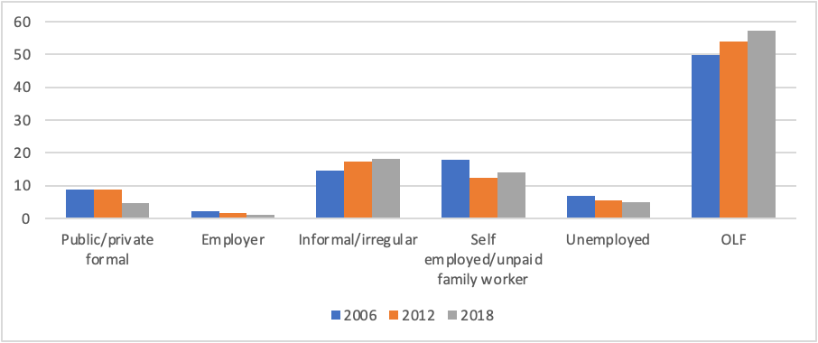
Figure 2: youth employment status across the three rounds of the survey.
Source: Authors’ graph.

Figure 2 shows the youth employment status across the three rounds of the survey (2006, 2012 and 2018). The results show the spread of informality and irregularity as a work status among the youth between 2006 and 2018. Breaking it down by gender, Figure 3 shows that most females are out of the labor force, where most males are in the informal/irregular job category. This highlights the spread of informality among the young males.

Table 1: Summary statistics
Variable | 2006  Mean  (st. error) | 2012  Mean  (st. error) | 2018  Mean  (st. error)
Educational attainment
Illiterate | 0.13 | 0.12 | 0.09
Read and write | 0.03 | 0.02 | 0.03
less than secondary | 0.24 | 0.3 | 0.34
Intermediate | 0.47 | 0.42 | 0.41
University and above | 0.11 | 0.13 | 0.11
Vulnerability
Inactive | 0.56 | 0.59 | 0.62
Non vulnerable | 0.08 | 0.08 | 0.04
Vulnerable | 0.34 | 0.31 | 0.33
Household size | 5.62  (2.65) | 4.84  (2.22) | 4.55  (1.87)
Average Temperature | 20.3  (2.88) | 25.95  (4.24) | 35.25  (3.83)
Average Humidity | 55.38  (13.5) | 41.36  (14.26) | 37.87  (13.68)
Average Precipitation | 0.29  (0.74) | 0.06  (0.31) | 0.1  (0.46)
Household wealth quintile
WIQ 1 | 0.18 | 0.19 | 0.19
WIQ 2 | 0.11 | 0.15 | 0.29
WIQ 3 | 0.18 | 0.25 | 0.17
WIQ 4 | 0.3 | 0.2 | 0.14
WIQ 5 | 0.21 | 0.19 | 0.19
Region
Greater Cairo | 0.13 | 0.09 | 0.06
Alex and Suez Canal | 0.1 | 0.07 | 0.05
Urban Lower Egypt | 0.13 | 0.1 | 0.09
Urban Upper Egypt | 0.14 | 0.14 | 0.13
Rural Lower Egypt | 0.25 | 0.28 | 0.28
Rural Upper Egypt | 0.22 | 0.3 | 0.38

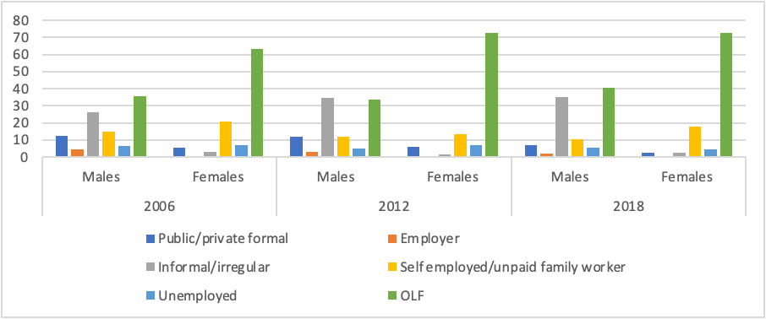
Figure 3: The gender disparities with respect to youth employment status across the three rounds of the survey.
Source: Authors’ graph.
Looking at the employment variability by the household wealth, Figure 4 shows that while inactivity (out of labor force and unemployment) as well as non-vulnerable employment dominate at the higher wealth quintiles, employment vulnerability is more prevalent at the lower wealth groups.

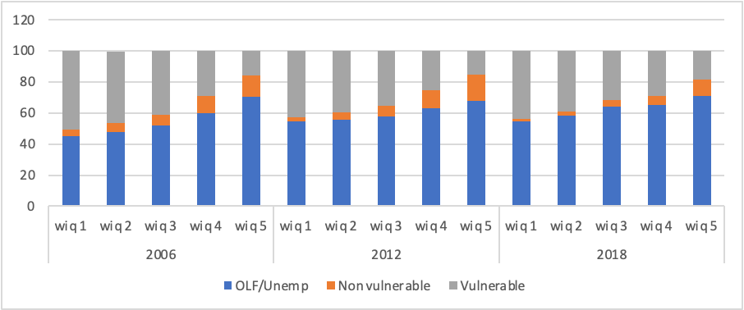
Figure 4: The wealth disparities with respect to employment vulnerability across the three rounds of the survey.
Source: Authors’ graph.

Furthermore, Figure 5 shows that despite the spread of employment vulnerability at the lower wealth quintiles, the share of vulnerable employment has increased between 2012 and 2018 among the top two wealth quintiles. Vulnerable employment is still considered the main employment option for the bottom two quintiles across the survey years. However, between 2012 and 2018 it is noticed that employment vulnerability started spreading across the top two quintiles.
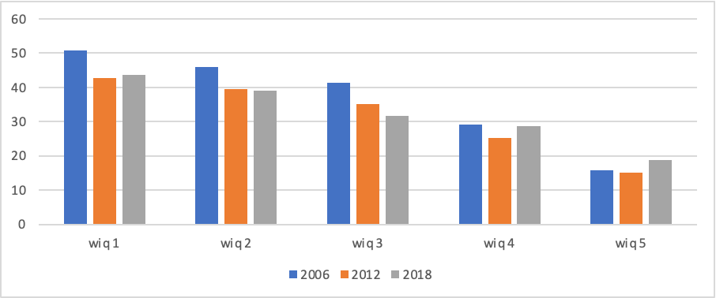
Figure 5: The spread of employment vulnerability at the lower wealth quintiles across the three rounds of the survey.
Source: Authors’ graph.
There is also a clear pattern represented in Figure 6, where employment vulnerability is more spread among sons with fathers having lower levels of education. Employment status of the father has less impact on that of the sons when compared to the education level of the father.

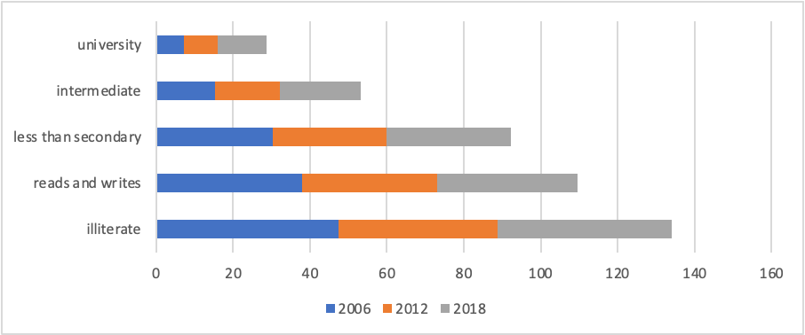
Figure 6: The interaction between employment vulnerability and father’s educational level across the three rounds of the survey.
Source: Authors’ graph.
- Methodology:
The study aims at investigating the following research questions: (1) How does climate change (measured by changes in temperature, precipitation, and humidity) impact employment vulnerability in Egypt? (2) How is respondents' vulnerability based on climatic changes impacted by the respondent's characteristics such as age range, educational level, and income? (3) How does climate change impact youth employment vulnerability in rural Egypt? (4) How does this impact differ between male and female labor groups? (5) How does climate change impact employment vulnerability in rural Egypt and the regional disparities?

We use the vulnerable employment variable while controlling for socioeconomic and demographic variables such as age, gender, education, wealth, ..., etc. Vulnerable employment variable, dependent variable, is a qualitative variable with three categories. We define vulnerable employment categories as the total of self-employment, unpaid family workers, irregular wage workers and informal private sector workers. The non-vulnerable category is formal employment and employer, and the base category is OLF and unemployed. With longitudinal survey data like ILMPS-climate integrated dataset, it is possible to analyze the transitions of individuals between different employment states using appropriate statistical techniques. For a categorical dependent variable with repeated observations one such model is the generalized linear mixed model (GLMM). The specific GLMM for a dependent variable with three or more categories is the multinomial logit model. This model is very computationally intensive, requiring a large amount of computer processing time that increases with the number of clusters (or individuals) in the data.

Multinomial logistic regressions are adopted to investigate the individual contributions of workers’ circumstances. This method has previously been used by Hlasny and AlAzzawi to study the static and dynamic nature of vulnerable employment in Egypt using 1998, 2006 and 2012 waves and Jordan using 2010 and 2016 waves, Assaad et al. to study occupational distribution of all workers in Jordan 2010, and by Assaad and Krafft to study school-to-work transitions in Egypt 2012 (Hlasny and AlAzzawi, 2018; Assaad 2014b; Assaad and Krafft 2014). The analysis is further extended to include interaction variables between climate change variables and the respondents' individual-level characteristics to identify how respondents' vulnerability based on climatic changes is impacted by the respondent's characteristics such as age range, educational level, and gender.

  - The model
Given the dependent variable an appropriate model is the multinomial logit model. Suppose that individual i has T categorical observations and let Y_{it} denote the t-th observation for individual i, t = 1,…,T. If there are J possible response states then $PrPr ( Y_{it}=j|X_{it})$, j = 1,…,J, is the probability that individual i has response j at time t given X_{it ,}a column vector of explanatory variables for that observation (Cameron and Trivedi, 2005; Greene, 2018)
The multinomial model is expressed as
$p_{itj}=PrPr ( Y_{it}=j|X_{it})=\frac{e^{X_{it}β_{j}}}{\sum_{k=1}^{J}{e^{X_{it}β_{k}}}}$.
Since $e^{X_{it}β_{j}}>0$ these probabilities lie between 0 and 1 and sum over j to one. Because $\sum_{k=1}^{J}{p_{itj}}=1$ an equivalent model is obtained by defining $X_{it}$ to be deviations of regressors from the values of alternative one and setting $X_{i1}=0$.

The coefficients in the multinominal logit models can be given a more direct logit-like interpretation in terms of relative risk. This is because the models can be re-expressed as binary logit models.

The multinomial logit model pairs each response category with an arbitrary baseline category. In our analysis the response has three states (J = 3): OLF/ unemployed (j = 1), vulnerable employment (j = 2) and non-vulnerable employment (j = 3). For identifiability, OLF/ unemployed is set as the reference category so that β₁ = 0. The multinomial logit model then has the form:
$loglog ( \frac{p_{itj}}{p_{it1}})=X_{it}^{'}β_{j}$
In this study it is appropriate to estimate the model where each individual i is now considered as a cluster of observations over time (t = 1,2,3).

As previously explained, we rely on matching ILMPS for Egypt, and a geographically gridded daily measures of climate. The impact of changes in the aforementioned climate variables in the respondent’s location of residence on the vulnerable employment during a given week reported by the respondent is examined. It should be noted that the location applied in the estimation is Markaz/Kism for Egypt. We exploit the spatial and temporal variation in our observations to identify the causal impact of temperature, humidity, and precipitation changes on labor market vulnerability in our study. We utilize the same econometric framework adopted by Hlasny and AlAzzawi where the respondent vulnerable employment during week t (Hlasny and AlAzzawi 2018). Our main explanatory variables of interest are climate variables and climate variables square which have several climate variables in the linear and second-degree polynomials. Climate variables are (1) weekly average of the maximum temperature faced by respondent i in week t in location s; (2) average humidity faced by respondent i in week t in location s; (3) average precipitation faced by respondent i in week t in location s. $X_{it}$ is a vector of individual-level characteristics which are controlled for including age minus 15 years, age minus 15 years-squared, gender, household size, female headed household, highest number of years of education in the household, regional distribution, father’s employment status and educational level of the individual and the father’s. We also control for the respondent’s wealth score, at the time of the survey which is expected to impact a respondent’s willingness to relocate between employment status. We also include round fixed effects to capture the evolution of vulnerable employment over time.

- Results and discussion
Table 2 shows the most restrictive model showing strictly the impact of climate change on employment vulnerability among youth aged 15-29 in Egypt across the three survey years. Separately and combined, the rise in temperature and humidity has a significant impact on the odds of vulnerable employment. While the temperature has a negative linear impact, humidity has an inverted u-shaped impact on the odds of vulnerable employment. The interaction of both variables indicates that, when the rise in temperature is amplified by a rise in humidity, above the maximum average, for the time period and the region, the odds of vulnerable, and a non-vulnerable employment both decrease as compared to the inactive status.

Table 2: Multinomial logistic regression for the impact of climate on employment vulnerability.
 | Vulnerable | Non-vulnerable
Weekly average maximum temperature | 0.063*** | 0.001
 | (0.008) | (0.012)
Weekly average relative humidity | 0.104*** | 0.045***
 | (0.012) | (0.017)
Weekly average relative humidity squared | -0.001*** | -0.000**
 | 0.000 | 0.000
Weekly average precipitation | 0.026 | -0.223***
 | (0.047) | (0.033)
Weekly average precipitation squared | (0.017) | 0.035***
 | (0.011) | (0.007)
Temperature*Humidity | -0.002*** | -0.001**
 | 0.000 | 0.000
constant | -3.624*** | -1.909***
 | (0.349) | (0.576)
N | 106756 | 106756
Clusters | 47017 | 47017
Chi-squared | 636 | 636
Pseudo R-Square | 0.0044 | 0.0044
Note: robust standard errors clustered at individual level are in parentheses; *** p<0.01, ** p<0.05, * p<0.1.
Source: authors’ calculations based on ILMPS for Egypt 2006–2018.

Table 3 controls for other explanatory variables in the attempt to explain the impact of climate change on the odds of vulnerable employment status as opposed to being inactive. The first explanatory variable, workers’ age is positively affecting the odds of vulnerable or a non-vulnerable employment, as opposed to inactivity. With a negative coefficient on the age squared, the effect is diminishing with age. Women have lower odds of any type of employment (vulnerable or a non-vulnerable) as opposed to being inactive.

Table 3: Multinomial logistic regression for the impact of climate as well as the other socio- economic variables on employment vulnerability.
 | Vulnerable | Non-vulnerable
age_min | 0.193*** | 0.378***
 | (0.003) | (0.005)
age_minsq | -0.004*** | -0.006***
 | 0.000 | 0.000
Female=1 | -2.390*** | -5.308***
 | (0.058) | (0.086)
Read & write | -1.160*** | -0.687***
 | (0.054) | (0.071)
Less than intermediate | -0.787*** | -0.505***
 | (0.052) | (0.067)
Intermediate | -0.375*** | 0.305***
 | (0.055) | (0.066)
University+ | -0.353*** | 1.010***
 | (0.075) | (0.083)
Female * Read & Write | 1.278*** | 1.054***
 | (0.075) | (0.218)
Female * Less than intermediate | 0.932*** | 1.217***
 | (0.064) | (0.152)
Female * Intermediate | 0.271*** | 2.676***
 | (0.063) | (0.095)
Female * University+ | 0.245*** | 3.580***
 | (0.090) | (0.108)
Household wealth score | -0.199*** | 0.102***
 | (0.016) | (0.019)
Household size | 0.026*** | -0.031***
 | (0.005) | (0.007)
Female headed | (0.026) | 0.037
 | (0.029) | (0.041)
Edu max yrs in hhd | -0.046*** | -0.016***
 | (0.003) | (0.005)
Father Read & Write | -0.131*** | 0.050
 | (0.029) | (0.035)
Father Less than intermediate | -0.201*** | 0.085**
 | (0.032) | (0.042)
Father Intermediate | -0.568*** | (0.032)
 | (0.035) | (0.045)
Father University+ | -0.868*** | (0.015)
 | (0.060) | (0.059)
Father Employer | 0.414*** | 0.631***
 | (0.029) | (0.037)
Father Self Employed | 0.144*** | (0.041)
 | (0.030) | (0.043)
Father Unpaid Fam. Wrkr./Non-employed | 0.356*** | 0.331***
 | (0.039) | (0.056)
Egypt-Alx Sz C. | 0.065 | 0.472***
 | (0.075) | (0.075)
Egypt-Urb. Lwr. | 0.474*** | 0.387***
 | (0.047) | (0.058)
Egypt-Urb. Upp. | 0.487*** | 0.688***
 | (0.050) | (0.061)
Egypt-Rur. Lwr. | 1.035*** | 1.095***
 | (0.045) | (0.053)
Egypt-Rur. Upp. | 0.971*** | 1.035***
 | (0.047) | (0.059)
Wave of the survey (year)=2012 | -0.326*** | -0.689***
 | (0.048) | (0.051)
Wave of the survey (year)=2018 | -0.191** | -1.293***
 | (0.074) | (0.088)
Weekly average maximum temperature | 0.092*** | 0.076***
 | (0.010) | (0.013)
Weekly average relative humidity | 0.168*** | 0.140***
 | (0.013) | (0.018)
Weekly average relative humidity squared | -0.001*** | -0.001***
 | 0.000 | 0.000
Weekly average precipitation - EG | (0.049) | -0.181***
 | (0.050) | (0.052)
Weekly average precipitation squared | (0.017) | 0.023**
 | (0.014) | (0.010)
Temperature*Humidity | -0.002*** | -0.002***
 | 0.000 | 0.000
constant | -5.234*** | -7.925***
 | (0.461) | (0.632)
N | 105704 | 105704
Clusters | 46629 | 46629
Chi-squared | 26503.3 | 26503.3
Pseudo R-Square | 0.3708 | 0.3708
Note: robust standard errors clustered at individual level are in parentheses; *** p<0.01, ** p<0.05, * p<0.1.
Source: authors’ calculations based on ILMPS for Egypt 2006–2018.

Education shows a consistently negative effect on the odds of vulnerable employment. The effect on reducing the odds is highest among the lower levels of education and the effect diminishes with higher levels of education. Contrarily, higher levels of education increase the odds of non-vulnerable employment as opposed to inactivity. This confirms the MENA employment paradox where the highly educated would rather stay with no job rather than join an informal or irregular job.

Looking at the gender interaction with education, the positive coefficients highlight that the odds of being employed (in a vulnerable or a non-vulnerable status) is higher for educated women. It is noticed, however, that the coefficients are rising with education in the public/private formal sector jobs while declining with education for the informal/irregular ones. This shows that educated females are in search of the public/sector formal jobs rather than being inactive.

Household wealth has a positive effect on workers’ odds of becoming employed in a public/private formal job, with a negative effect on the odds of attaining informal or irregular jobs. Workers in larger households have slightly higher odds of joining the labor force but in a vulnerable job status, but lower odds of a non-vulnerable one. This suggests that in larger households, individuals are more open to accepting any type of job to support their larger families.

The highest level of education among household members is associated negatively with the odds of any type of labor market participation (vulnerable and non-vulnerable). Father’s education status is also associated negatively but only with the odds of landing an informal/irregular job. The impact on the public/private formal employment is insignificant. The father’s employment status has strong effects on the transmission of employment vulnerability through generations.

Across Egyptian regions, rural workers have significantly higher odds of being employed in an informal/irregular job than remaining inactive when compared to urban workers or to those in the metropolitan governorates of Greater Cairo, Alexandria, and Suez Canal governorates. This suggests the spread of employment vulnerability in rural areas more strongly than in other regions in Egypt.

The model is re-estimated for rural youth to allow for further understanding of the impact of climate change on the youth employment vulnerability in rural Egypt (results reported in table 4 below). With all the variables showing similar signs and significance, few variables are worth discussing given the magnitude of their impact on employment vulnerability among rural youth.

Table 4: Multinomial logistic regression for the impact of climate as well as the other socio- economic variables on rural youth employment vulnerability.
 | Vulnerable | Non-vulnerable
age_min | 0.238*** | 0.673***
 | (0.016) | (0.061)
age_minsq | -0.005*** | -0.017***
 | (0.001) | (0.003)
Female | -2.569*** | -5.074***
 | (0.120) | (0.392)
Read & write | -0.413** | 0.194
 | (0.167) | (0.254)
Less than intermediate | -1.027*** | -0.757***
 | (0.105) | (0.181)
Intermediate | -0.944*** | -0.393**
 | (0.105) | (0.176)
University+ | -1.036*** | 0.031
 | (0.143) | (0.218)
Female * Read & Write | 0.552** | -12.186***
 | (0.214) | (0.449)
Female * Less than intermediate | 1.508*** | 1.380**
 | (0.127) | (0.561)
Female * Intermediate | 1.062*** | 2.692***
 | (0.122) | (0.408)
Female * University+ | 0.964*** | 3.500***
 | (0.177) | (0.420)
Household wealth score | -0.118*** | 0.231***
 | (0.027) | (0.050)
Household size | 0.033*** | -0.082***
 | (0.008) | (0.018)
Female headed | 0.025 | (0.021)
 | (0.053) | (0.094)
Edu max yrs in hhd | -0.058*** | (0.020)
 | (0.007) | (0.015)
Father Read & write | (0.038) | 0.112
 | (0.049) | (0.092)
Father Less than intermediate | -0.152*** | 0.136
 | (0.054) | (0.108)
Father Intermediate | -0.459*** | 0.014
 | (0.054) | (0.102)
Father University+ | -0.928*** | 0.010
 | (0.108) | (0.136)
Father Employer | 0.596*** | 0.572***
 | (0.045) | (0.088)
Father Self Employed | 0.112* | 0.079
 | (0.065) | (0.118)
Father Unpaid Fam. Wrkr./Non-employed | 0.528*** | 0.474***
 | (0.065) | (0.128)
Egypt-Rur. Lwr. | 1.479*** | 1.086**
 | (0.460) | (0.455)
Egypt-Rur. Upp. | 1.429*** | 0.788*
 | (0.459) | (0.456)
Wave of the survey (year)=2012 | -0.313*** | -0.803***
 | (0.066) | (0.110)
Wave of the survey (year)=2018 | -0.197* | -1.646***
 | (0.115) | (0.195)
Weekly average maximum temperature | 0.097*** | 0.092***
 | (0.014) | (0.027)
Weekly average relative humidity | 0.175*** | 0.157***
 | (0.018) | (0.037)
Weekly average relative humidity squared | -0.001*** | -0.001***
 | 0.000 | 0.000
Weekly average precipitation | -0.317*** | -0.636***
 | (0.109) | (0.198)
Weekly average precipitation squared | 0.068** | 0.196***
 | (0.033) | (0.054)
Temperature*Humidity | -0.003*** | -0.002***
 | 0.000 | (0.001)
constant | -5.779*** | -9.175***
 | (0.773) | (1.335)
N | 22751 | 22751
Clusters | 11737 | 11737
Chi-squared | 31129.300 | 31129.300
Pseudo R-Square | 0.221 | 0.221
Note: robust standard errors clustered at individual level are in parentheses; *** p<0.01, ** p<0.05, * p<0.1.
Source: authors’ calculations based on ILMPS for Egypt 2006–2018.

The impact of education on employment status is compounded in rural areas. The effect on the odds of employment vulnerability is still negative but with a stronger impact. The effect is even larger for educated females. Moreover, the rural variables show a strong and positive impact on the odds of employment vulnerability as opposed to being in a non-vulnerable employment or inactive.

Finally, the climate factors are showing similar impact in the collective model and the rural youth model. We notice in both models that the climate variables have a significant impact on the odds of employment vulnerability. The rise in temperature above the maximum reported average indicates higher odds of being in any kind of employment, the effect is strongest on the odds of youth vulnerable employment in rural areas. Relative humidity is showing an inverted u-shaped effect on the odds of vulnerability, with the highest effect being in rural areas. The increase in precipitation is showing a u-shaped relationship with the odds of any type of employment. Moreover, the negative and significant coefficient of the interaction variable of temperature and humidity shows that for both rural and urban areas, a rise in temperature compounded by a rise in humidity reduces the odds of being in any type of employment where individuals prefer to remain inactive.

- Conclusion and Policy implications
This paper has defined youth employment vulnerability and the impact of climate change variables on the odds of this vulnerability for youth. We combined two data sets to allow for this combined analysis for the impact of climate change on labor market outcomes. We found that youth, especially in rural areas, end up in vulnerable jobs as opposed to non-vulnerable formal sector ones. Moreover, the data shows that in multiple cases, youth prefer to remain in their status of employment vulnerability rather than being inactive. The analysis also shows that climate change is compounding the employment vulnerability of youth both in rural and urban areas with more severe impact in rural areas.

The results of the paper highlight that it is important to analyze the labor market performance not through the extent of unemployment and inactivity but more so through informality and vulnerability of employment. Vulnerable employment is spread across rural and urban areas, but the severity of it is higher among youth in rural areas, where formal jobs are scarce.

Rural sector development programs that are gender sensitive and ensure equitable resource distribution improves the capacity of rural youth to adjust to climate change. This will require the collaborative role of the government agencies, the civil society organizations, and the private individuals. Access to information, training and services would allow the rural population to adapt to new practices that would aim to mitigate the impact of climate change and improve their vulnerability.

- References

Abou-Ali, H., Hawash, R., Ali, R., & Abdelfattah, Y. (n.d.). Is It Getting Too Hot to Work in the MENA Region? Economic Research Forum. https://erf.org.eg/publications/is-it-getting-too-hot-to-work-in-the-mena-region-2/

Abou-Ali, H., & Rizk, R. (2015). MSEs Informality and Productivity: Evidence from Egypt (Working Paper No. 916). Economic Research Forum. https://econpapers.repec.org/paper/ergwpaper/916.htm

Adam-Poupart, A., Labrèche, F., Smargiassi, A., Duguay, P., Busque, M.-A., Gagné, C., Rintamäki, H., Kjellstrom, T., & Zayed, J. (2013). Climate change and Occupational Health and Safety in a temperate climate: Potential impacts and research priorities in Quebec, Canada. Industrial Health, 51(1), 68–78. https://doi.org/10.2486/indhealth.2012-0100

Antonelli, C., Coromaldi, M., Dasgupta, S., Emmerling, J., & Shayegh, S. (2021). Climate impacts on nutrition and labor supply disentangled – an analysis for rural areas of Uganda. Environment and Development Economics, 26(5–6), 512–537. https://doi.org/10.1017/S1355770X20000017

Arora, D., Arango, J., Burkart, S., Chirinda, N., & Twyman, J. (2017). Gender [im]balance in productive and reproductive labor among livestock producers in Colombia: Implications for climate change responses. https://cgspace.cgiar.org/handle/10568/79940

Assaad, R. (2007). Youth in the Middle East and North Africa: Demographic opportunity or challenge. … Reference Bureau MENA Policy Brief, April. https://www.academia.edu/911666/Youth_in_the_Middle_East_and_North_Africa_Demographic_opportunity_or_challenge

Assaad, R. (2014a). The Jordanian Labour Market in the New Millennium. OUP Oxford.

Assaad, R. (2014b). Making sense of Arab labor markets: The enduring legacy of dualism. IZA Journal of Labor & Development, 3(1), 6. https://doi.org/10.1186/2193-9020-3-6

Assaad, R., AlSharawy, A., & Salemi, C. (n.d.). Is the Egyptian Economy Creating Good Jobs? Job Creation and Economic Vulnerability from 1998 to 2018 (No. 1354; Working Paper Series, p. 52). Economic Research Forum. https://erf.org.eg/app/uploads/2019/10/1354-updated-2.pdf

Assaad, R., & Krafft, C. (2013). The Structure and Evolution of Employment in Egypt: 1998-2012. Economic Research Forum Working Paper Series. https://doi.org/10.1093/acprof:oso/9780198737254.003.0002

Assaad, R., & Krafft, C. (2014). Youth Transitions in Egypt: School, Work, and Family Formation in an Era of Changing Opportunities (No. 14–1). Silatech. https://www.silatech.org/wp-content/uploads/2018/12/youth-transitions-in-egypt-school-work-and-family-formation-in-an-era-of-changing-opportunities.pdf
Assaad, R., & Krafft, C. (2015). The Egyptian Labor Market in an Era of Revolution. OUP Oxford.

Assaad, R., Krafft, C., & Selwaness, I. (2017). The Impact of Early Marriage on Women’s Employment in the Middle East and North Africa (Working Paper No. 66). GLO Discussion Paper. https://www.econstor.eu/handle/10419/157645

Barsoum, G., Ramadan, M., & Mostafa, M. (2014). Labour market transitions of young women and men in Egypt (No. 16; Work4Youth Publication Series, p. 72). International Labour Organization. https://www.ilo.org/wcmsp5/groups/public/---dgreports/---dcomm/documents/publication/wcms_247596.pdf

The Egyptian Center for Economic Studies (ECES). (2020). Views on crisis—The informal economy. http://www.eces.org.eg/cms/NewsUploads/Pdf/2020_4_9-13_8_27informal%20sector-%20final%20-%20English%20%20(ebrahim).pdf

Hlasny, V., & AlAzzawi, S. (2019). Asset inequality in the MENA: The missing dimension? The Quarterly Review of Economics and Finance, 73, 44–55. https://doi.org/10.1016/j.qref.2018.07.010

International Center for Migration Policy Development (ICMPD). (2020). Linking human capital, labour markets and international mobility: An assessment of challenges in Egypt, Jordan, Morocco and Tunisia. https://www.icmpd.org/news/import-news-september/linking-human-capital-labour-markets-and-international-mobility-an-assessment-of-challenges-in-egypt-jordan-morocco-and-tunisia

International Labour Organization. (2018). The employment impact of climate change adaptation – Input Document for the G20 Climate Sustainability Working Group (p. 40). https://www.ilo.org/wcmsp5/groups/public/---ed_emp/documents/publication/wcms_645572.pdf

International Labour Organization (ILO). (2020). ILO monitor: COVID-19 and the world of work | VOCEDplus, the international tertiary education and research database. https://www.voced.edu.au/content/ngv:85921

Laithy, H. E., Lokshin, M., & Banerji, A. (2003). Poverty and Economic Growth in Egypt, 1995-2000. World Bank Publications.

OAMDI (2019). Labor Market Panel Surveys (LMPS). Egypt: Economic Research Forum (ERF). http://erf.org.eg/data-portal/.

Quick, J. C., Bennett, J., & Blake Hargrove, M. (2014). Stress, Health, and Wellbeing in Practice. In Wellbeing (pp. 1–30). John Wiley & Sons, Ltd. https://doi.org/10.1002/9781118539415.wbwell026

Shayegh, S., Manoussi, V., & Dasgupta, S. (2021). Climate change and development in South Africa: The impact of rising temperatures on economic productivity and labour availability. Climate and Development, 13(8), 725–735. https://doi.org/10.1080/17565529.2020.1857675
Smallholders and Family Farmers (Sustainability Pathways). (2012). Food and Agriculture Organization. https://www.fao.org/fileadmin/templates/nr/sustainability_pathways/docs/Factsheet_SMALLHOLDERS.pdf

World Bank. (2019). Understanding Poverty and Inequality in Egypt. https://openknowledge.worldbank.org/bitstream/handle/10986/32812/Understanding-Poverty-and-Inequality-in-Egypt.pdf;jsessionid=6254AFB27CEBCCEC3A382CEED87D0C7B?sequence=1

For the case of Egypt 1988 and Egypt 1998 rounds, the labor datasets do not include the date of the interview variable. Therefore, weekly averages for the climate variables are not calculated for these two rounds and they are dropped from the analysis.

